CE213 Class Problem Sheet 1 (Week 2)
Introduction to Lab Exercises at Your Own Time (via CE213 Moodle website):
https://moodle.essex.ac.uk/course/view.php?id=3651

Lab exercise 1: at your own time after Week 3, to solve the corn, goose and fox problem by
implementing breath first search in Java.
Lab exercise 2: at your own time after Week 4, to create an AI player for the tic-tac-toe board game
by implementing minimax search and alpha-beta pruning algorithm in Java.
Lab exercise 3: at your own time after Week 9, to solve the XOR problem or data classification
problem by implementing the error backpropagation learning algorithm for training
a multilayer perceptron (MLP) in Java.

(Q1) Review relevant lecture notes and explain what are meant by the following terms:
i. Lady Lovelace’s Objection
ii. The Turing Test
iii. Searle’s Chinese Room
iv. Weak AI and Strong AI
(Other related terms: artificial general intelligence (AGI), general AI, specialised AI, narrow AI)

(Q2) Multiple choice questions:

(i) Who coined the term ‘artificial intelligence’?
[A] Lady Lovelace
[B] John McCarthy
[C] Alan Turing
[D] Aristotle

(ii) The Turing Test is:
[A] A proof that artificial intelligence is possible
[B] A refutation of Lady Lovelace’s Objection
[C] A criterion that would evaluate whether a machine has achieved weak AI
[D] All of the above

(iii) Which of the following is true about state space representation of a problem?
[A] The state space cannot be infinite
[B] There must be at most one goal state
[C] There must be more than one operator
[D] None of the above

(Q3) Assume that in the “three jugs problem” the capacities of the three jugs are 8, 5 and 3 litres respectively, the total amount of liquid available is 8 litres, and the basic volume unit for decanting operation is 1 litre (i.e., always make the destination jug full if possible).
- Work out how many different states there are in the “three jugs problem”.
- Find at least one solution to the “three jugs problem” by constructing a search tree with initial state as [8 0 0] and goal state as [4 4 0].
e.g.,
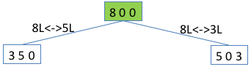
(continue building up the tree till reaching the goal state)

More questions for homework:

What are the limitations of the Turing Test?
How would AI impact on the job market in 5~10 years?
How can we stay competitive in the age of AI?
What are the grand challenges in AI?
……

If you are interested, have a look at the Leobner Prize, an annual competition in AI:

In 1990, Hugh Loebner, an American businessman, set up a contest designed to implement the Turing Test (https://en.wikipedia.org/wiki/Loebner_Prize).

“A Grand Prize of $100,000 and a Gold Medal will be awarded for the first computer whose responses are indistinguishable from a human's. In addition, each year an annual prize and a bronze medal are awarded to the most human-like computer. The winner of the annual contest is the best entry relative to other entries that year, irrespective of how good it is in an absolute sense.”

Nobody has received the Grand Prize / Gold Medal by now: No program entered for this contest has passed the Turing test!

Is this a useful contribution to the development of artificial intelligence?

Topics: Introduction to AI, state space representation

Answers or hints:

Q1: Find answers from lecture notes.

Q2: (i) B; (ii) C; (iii) D.

Q3:
Let x, y, z be the contents in the 8 litre jug, 5 litre jug and 3 litre jug respectively. They should satisfy the following constraints: 0≤x≤8, 0≤y≤5, 0≤z≤3; x+y+z=8; x,y,z are integers.
There are 9 possible contents of the 8 litre jug: 8,7,6,5,4,3,2,1,0, for each of which we can find out the number of possible contents in the 5 litre jug and 3 litre jug.
There are 24 (=1+2+3+4+4+4+3+2+1) different states as follows:

8,0,0
7,1,0
7,0,1
6,2,0
6,1,1
6,0,2
5,3,0
5,2,1
5,1,2
5,0,3
4,4,0
4,3,1
4,2,2
4,1,3
3,5,0
3,4,1
3,3,2
3,2,3
2,5,1
2,4,2
2,3,3
1,5,2
1,4,3
0,5,3

Removing constraint x+y+z=8: There are 216 (=9x6x4) different states.
Removing constraint that x, y, z are integers: There could be infinite states.

Search tree (incomplete):
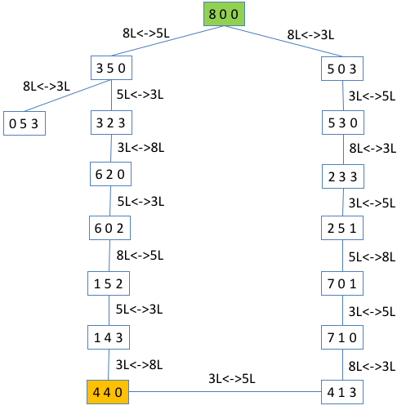

More questions for homework:

The Turing Test involves natural language processing tasks only. The expert panel (interrogators/judges) may be biased. The human player/actor may not be selected appropriately. It is not valid for assessing strong AI as it is based on a behavioural argument. It may not be the best criterion/approach for evaluating AI.
(What would you suggest as a better test for assessing AI?)

New jobs created due to advances in AI...
Jobs that may disappear due to AI…
Think about what challenges are in developing self-driving cars, personal service robots, AI for health-care, etc.

